ASSEMBLY REPORT



Date: 5 SEPTEMBER 2024 Organized by: Social Science Department
The Social Science Department organized an enlightening and inspiring assembly on September,5 2024, dedicated to the theme of the teachers day. The assembly was meticulously planned, incorporating various elements that highlighted the teachers day.
Anchoring and Introduction
The assembly was anchored by fabitha, who began the proceedings with a warm welcome to all students and teachers. She introduced the theme of the day.
Prayer
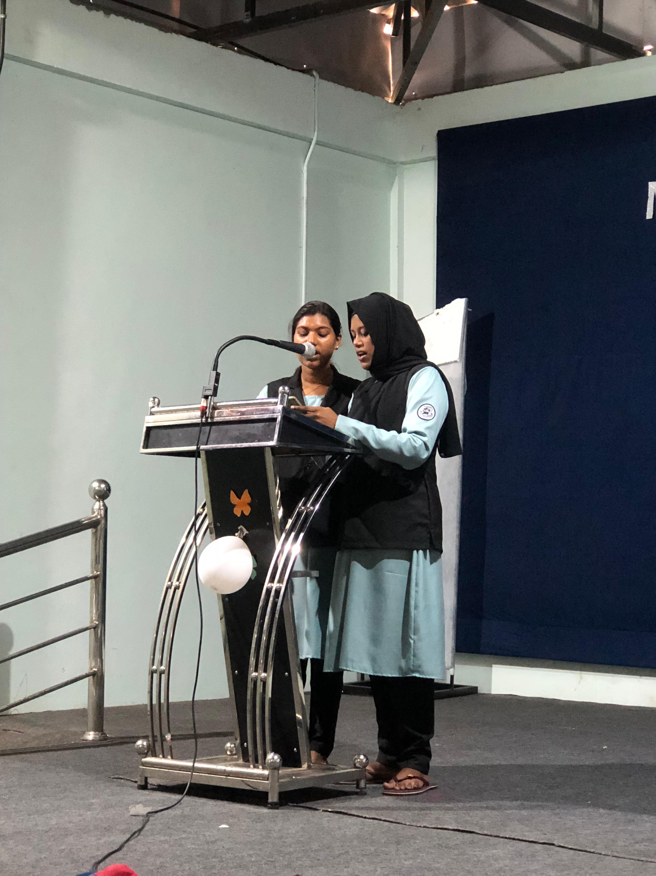
Suneera and vidhya led the assembly in a solemn prayer, setting a respectful and focused tone for the event.
Pledge
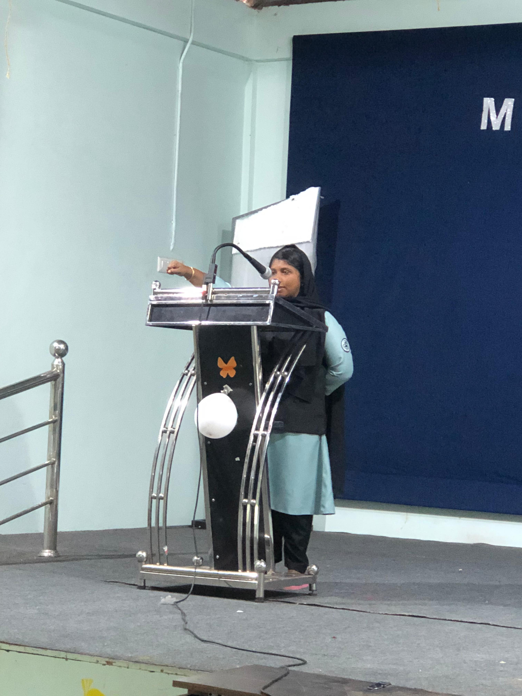
Aneesa Nargees then took the stage to lead the college in the Pledge, reaffirming the students’ commitment to their duties and responsibilities as citizens.
News Update
Ramseena provided the day’s news, keeping everyone informed about current events, with a special emphasis on the latest updates.
Thought of the Day
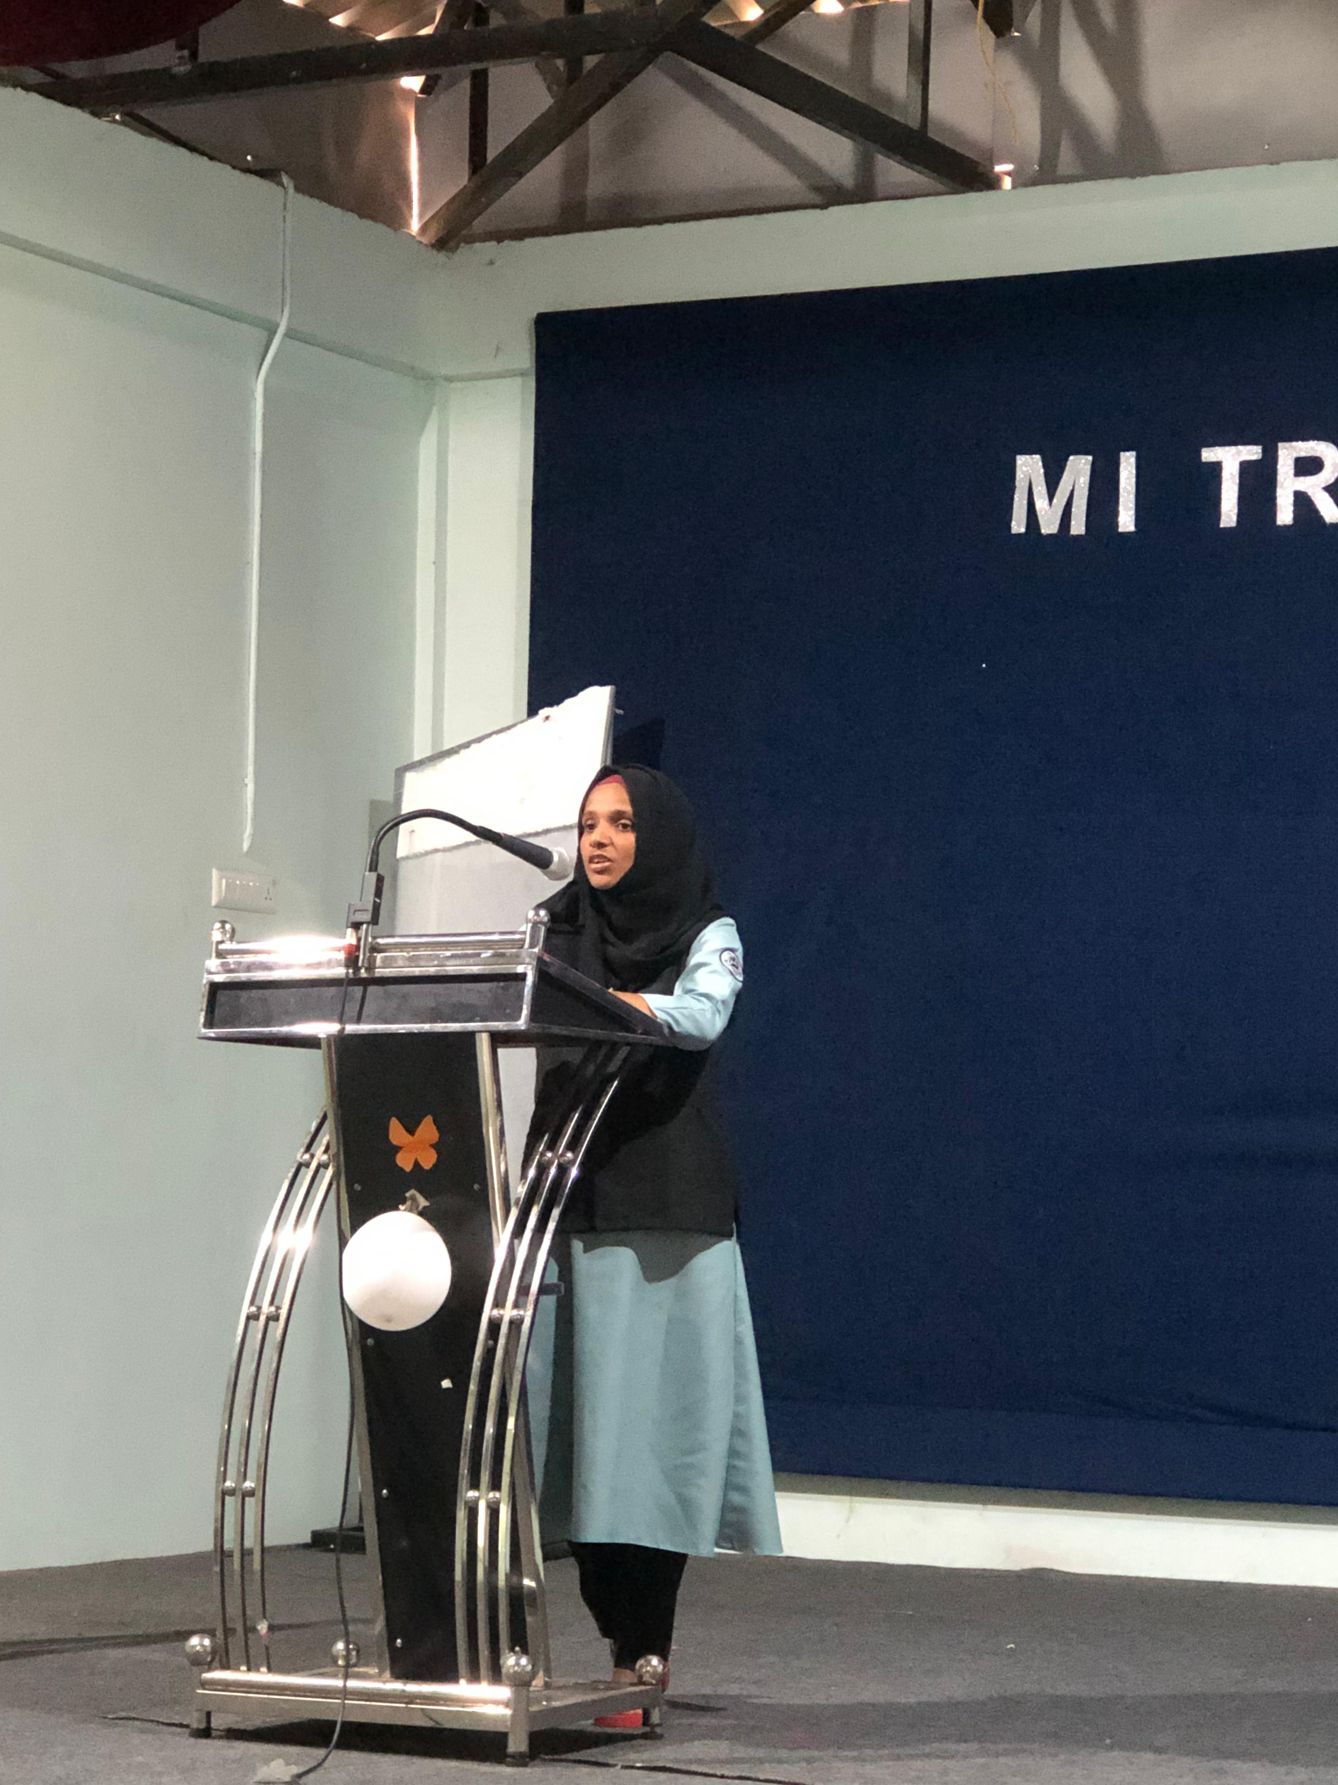
Sumayya shared an inspiring thought of the day,reminding everyone of the importance of teachers and teaching.

Holy Thought
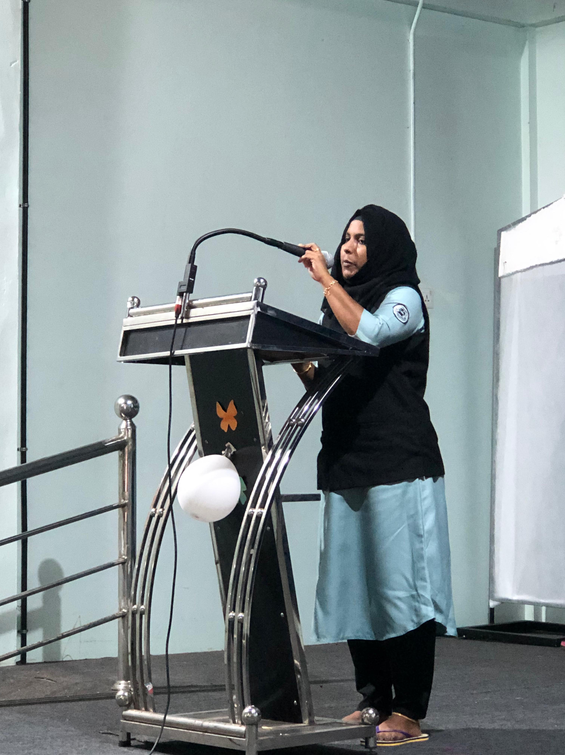
Suneera offered a holy thought, she shared insightful words of wisdom, providing guidance and inspiration to the audience.

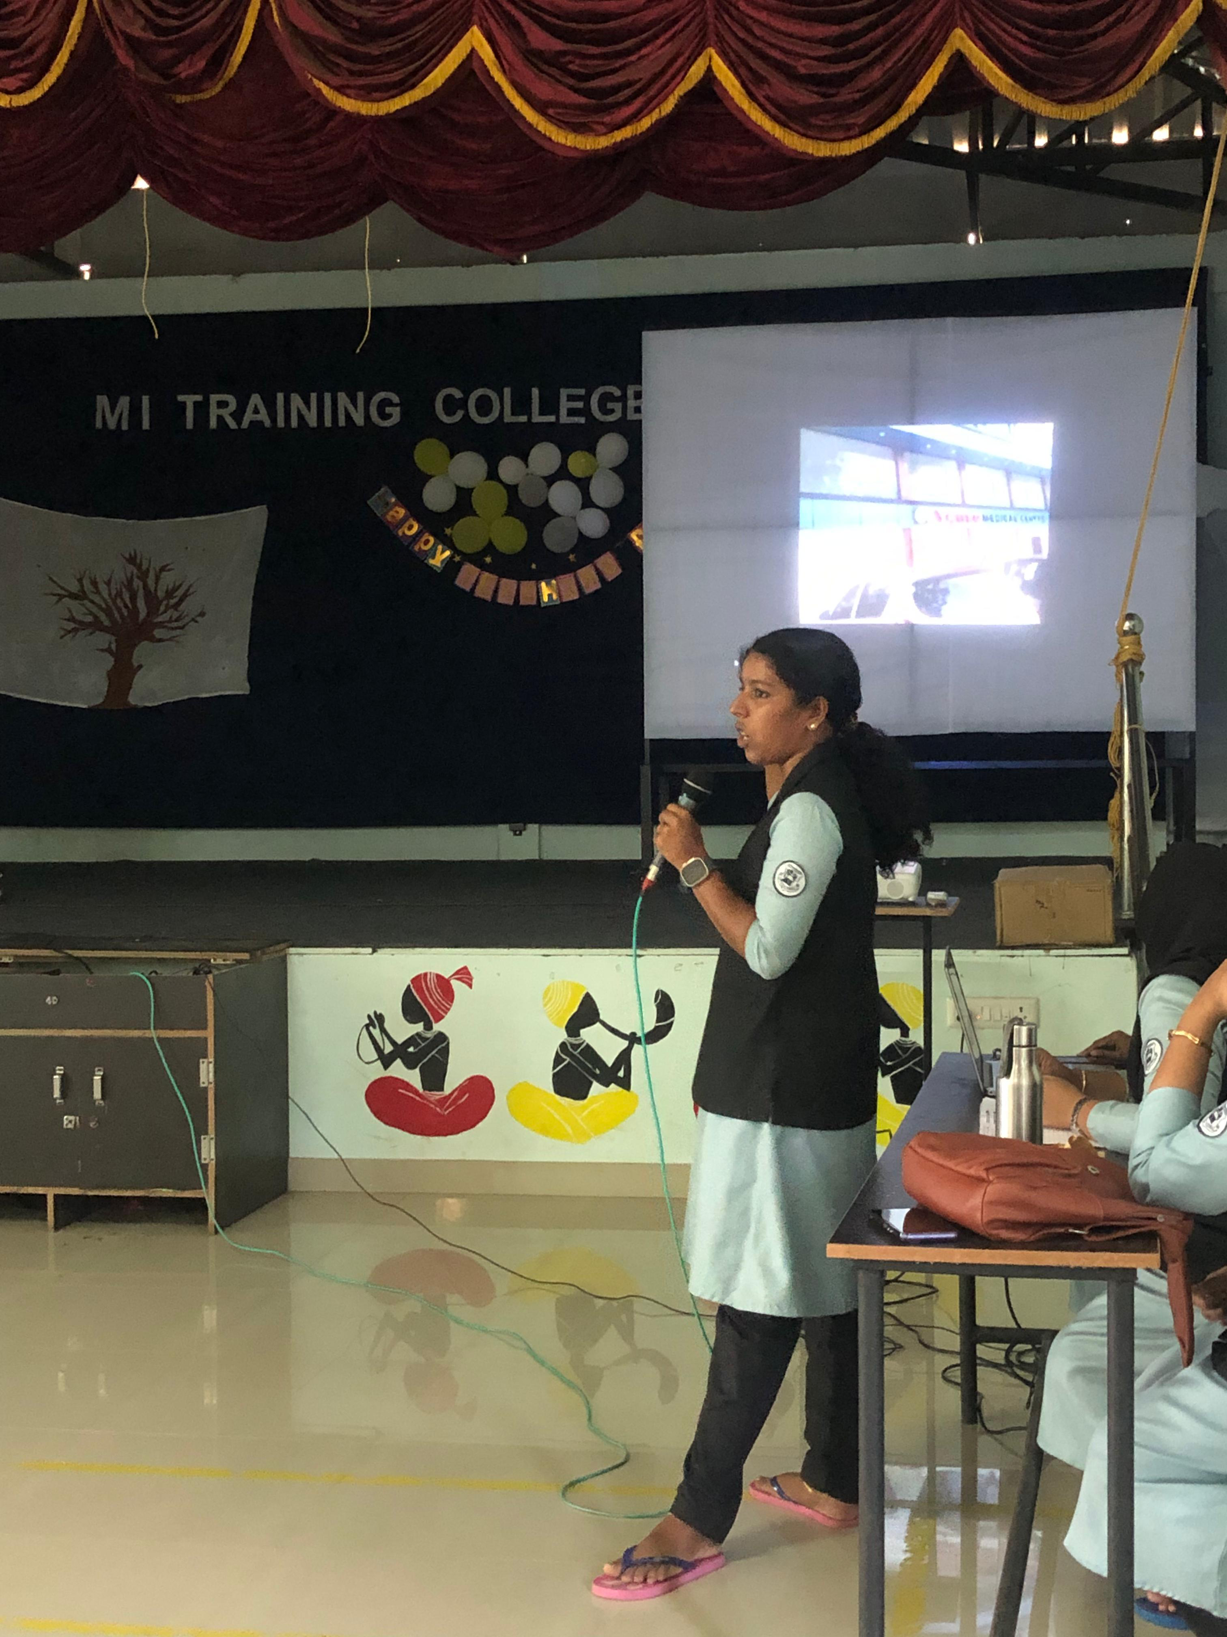
Today, the documentary “Ente Naadu”was presented by praveena. Through this she introduced her locality.
Conclusion
In conclusion, the program was a resounding success, thanks to the diverse range of segments and the talent of the presenters. The event showcased the power of collaboration and the importance of sharing knowledge and ideas, and was a testament to the strength of teamwork and dedication.

